PO3_Schedule

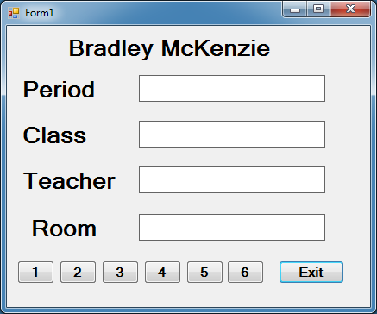

Private Sub btn1_Click(sender As System.Object, e As System.EventArgs) Handles btn1.Click

lblDisplay1.Text = "1"

lblDisplay2.Text = "Game Design 1"

lblDisplay3.Text = "Andersen, C"

lblDisplay4.Text = "G-109"

End Sub

Private Sub btn2_Click(sender As System.Object, e As System.EventArgs) Handles btn2.Click

lblDisplay1.Text = "2"

lblDisplay2.Text = "Draw/Paint 1/2"

lblDisplay3.Text = "Anthony, L"

lblDisplay4.Text = "F-103"

End Sub

Private Sub btn3_Click(sender As System.Object, e As System.EventArgs) Handles btn3.Click

lblDisplay1.Text = "3"

lblDisplay2.Text = "Physical Ed 9"

lblDisplay3.Text = "Mapes, T"

lblDisplay4.Text = "GYM"

End Sub

Private Sub btn4_Click(sender As System.Object, e As System.EventArgs) Handles btn4.Click

lblDisplay1.Text = "4"

lblDisplay2.Text = "Intro Lit/Comp"

lblDisplay3.Text = "Guiliano, D"

lblDisplay4.Text = "D-133"

End Sub

Private Sub btn5_Click(sender As System.Object, e As System.EventArgs) Handles btn5.Click

lblDisplay1.Text = "5"

lblDisplay2.Text = "Biology"

lblDisplay3.Text = "Olague, V"

lblDisplay4.Text = "B-101"

End Sub

Private Sub btn6_Click(sender As System.Object, e As System.EventArgs) Handles btn6.Click

lblDisplay1.Text = "6"

lblDisplay2.Text = "Geometry"

lblDisplay3.Text = "Harris,S"

lblDisplay4.Text = "E-231"

End Sub

Private Sub btnExit_Click(sender As System.Object, e As System.EventArgs) Handles btnExit.Click

Application.Exit()

End Sub

End Class